# Oracle REST Data Services Quick Start Guide

## About this tutorial

This tutorial is designed to let you get started quickly developing RESTful services using Oracle REST Data Services.

## Helpful information

Before you perform the actions in this tutorial, note the following prerequisites and recommendations:

* Ensure that you have Oracle REST Data Services installed *and* configured for a currently-supported Oracle database
* Ensure that you have installed a currently-supported version of:
  + Oracle SQL Developer
  + SQLcl

NOTE: The latest version of SQLcl can be obtained [here](https://www.oracle.com/database/sqldeveloper/technologies/sqlcl/download/) *or* through Homebrew with the following brew install --cask sqlcl command. Additional SQLcl installation information can be found on [Homebrew](https://formulae.brew.sh/cask/sqlcl#default).

NOTE: The latest version of Oracle SQL Developer can be obtained [here](https://www.oracle.com/database/sqldeveloper/technologies/download/).

* It is strongly recommended that you install a browser extension that enables you to view JSON in the web browser. Popular browser extensions include:
  + [JSON Formatter](https://chrome.google.com/webstore/detail/json-formatter/bcjindcccaagfpapjjmafapmmgkkhgoa) for Google Chrome
  + [JSONView Add-on](https://addons.mozilla.org/en-US/firefox/addon/jsonview/) for Mozilla Firefox

### This tutorial assumes the following

* Oracle REST Data Services has been installed and configured on the following server, port, and context path: localhost:8080/ords/
* Oracle REST Data Services is running in standalone mode
* Oracle REST Data Services installation was performed using a database *Basic Connection* type with the following attributes:
  + Server: localhost
  + Port: 1521
  + Service name:ORCLPDB1

IMPORTANT: The examples in this tutorial assume that Oracle REST Data Services has been installed and configured in a single instance database *or* Pluggable Database (PDB). The examples and images in this guide will refer to the PDB as ORCLPDB1.

### Available client applications for this tutorial

The examples in this tutorial can be completed with the choice of your client application:

* SQLcl
* Oracle Database Actions
* Oracle SQL Developer
* Additionally, certain sections of this tutorial will require the use of a web browser.

NOTE: For a complete list of currently supported web browsers, please refer [here](https://www.oracle.com/middleware/technologies/browser-policy.html).

### Getting Started with Oracle RESTful Services

This section will guide you through the following steps:

* Creating a new database user with required roles and privileges for RESTful access
* Creating a new database table
* Inserting data into the newly-created database table
* Creating a *Resource* by auto-REST-enabling the newly-created database table
* Accessing this new Resource via localhost
* NOTE: We recommend you follow the steps in this tutorial as closely as possible, including using the specified names for schemas and database objects. Once you have completed the tutorial as prescribed, feel free to try it again using alternate schema and database object names.

### Create a new user and REST-enable their schema

1. Using SQLcl, connect to your database as the SYS user.

* 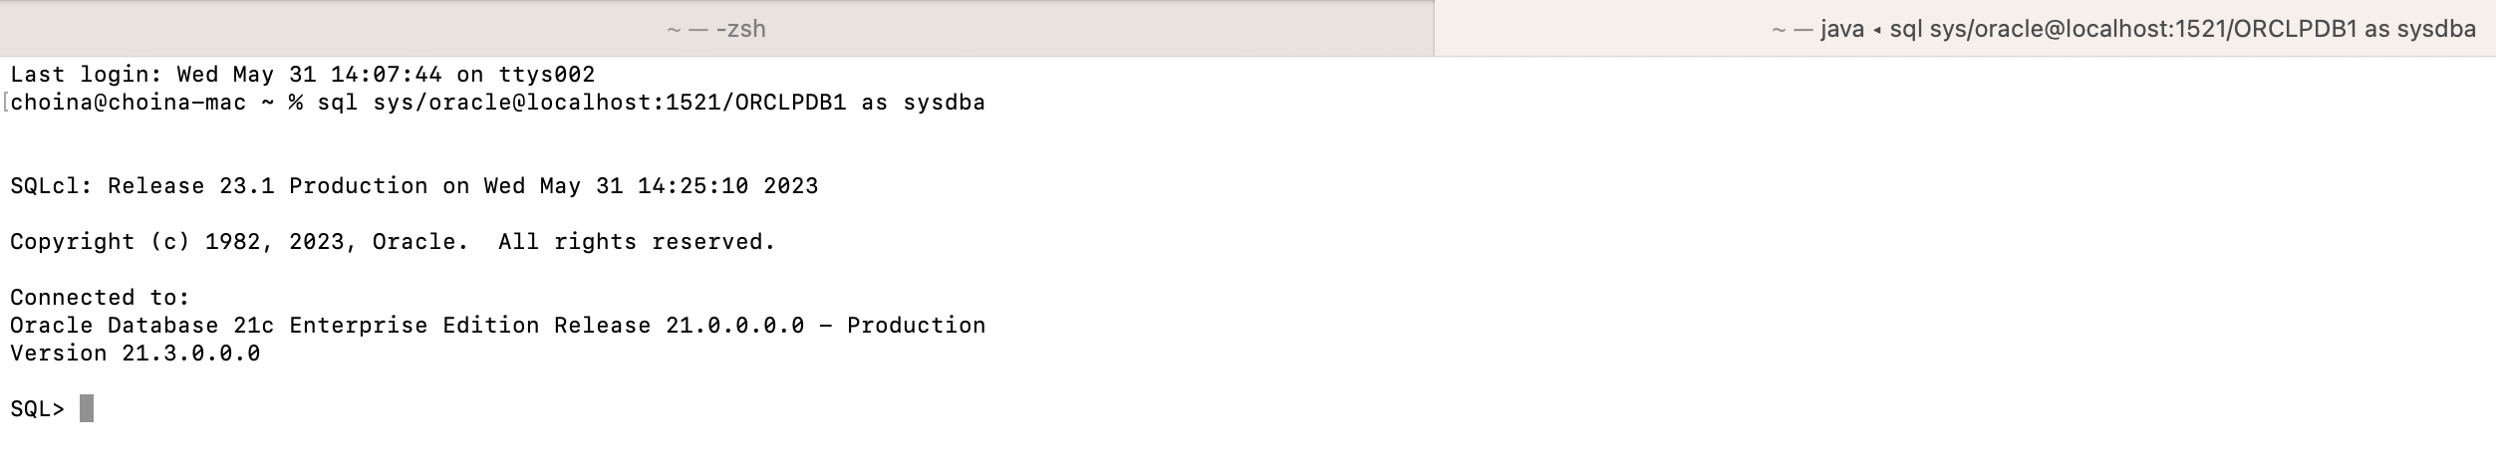 *Logging in with SQLcl as the SYS user*

1. Next, create a new ORDSTEST user with the following Privileges, Roles, and Tablespace Quota:

* CREATE USER ORDSTEST IDENTIFIED BY <password>;  
  GRANT "CONNECT" TO ORDSTEST;  
  GRANT "RESOURCE" TO ORDSTEST;  
  GRANT UNLIMITED TABLESPACE TO ORDSTEST;
* 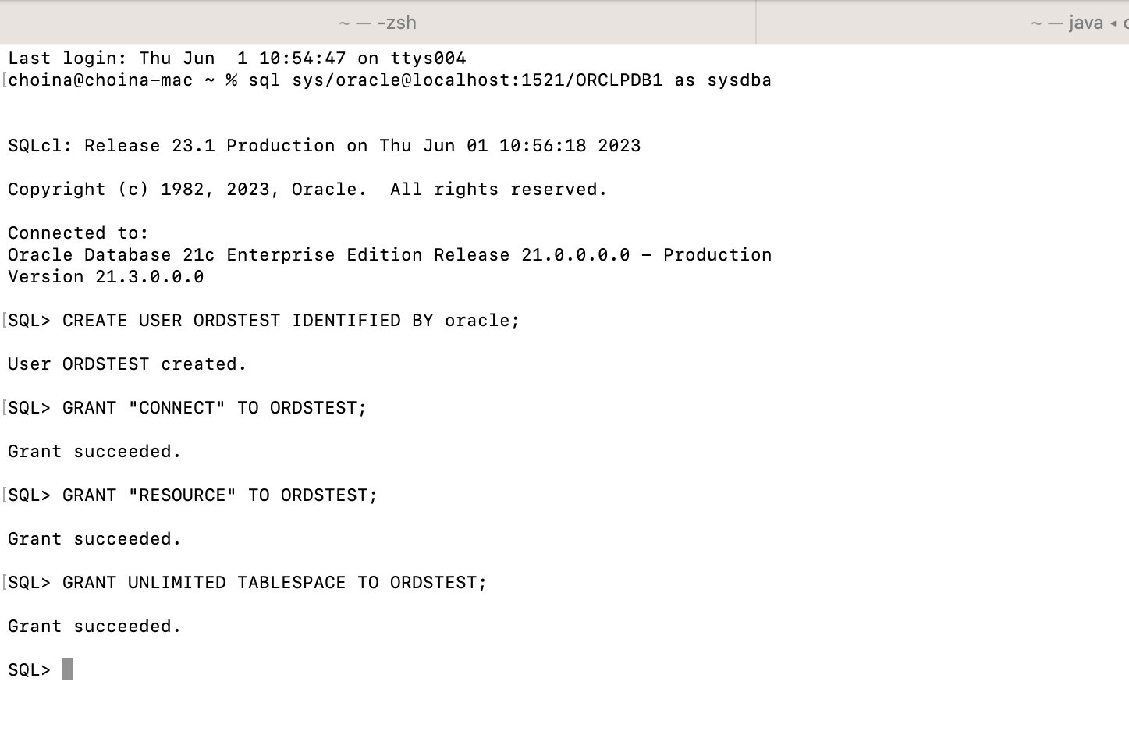 *Creating the ORDSTEST user with role, privilege, and tablespace quota*

1. Next, execute the ORDS_ADMIN.ENABLE_SCHEMA PL/SQL Procedure. This procedure grants the ORDSTEST user REST access.

* BEGIN  
   ORDS_ADMIN.ENABLE_SCHEMA(  
   P_ENABLED => TRUE,  
   P_SCHEMA => 'ORDSTEST',  
   P_URL_MAPPING_TYPE => 'BASE_PATH',  
   P_URL_MAPPING_PATTERN => 'ordstest',  
   P_AUTO_REST_AUTH => FALSE  
   );  
   COMMIT;  
  END;
* 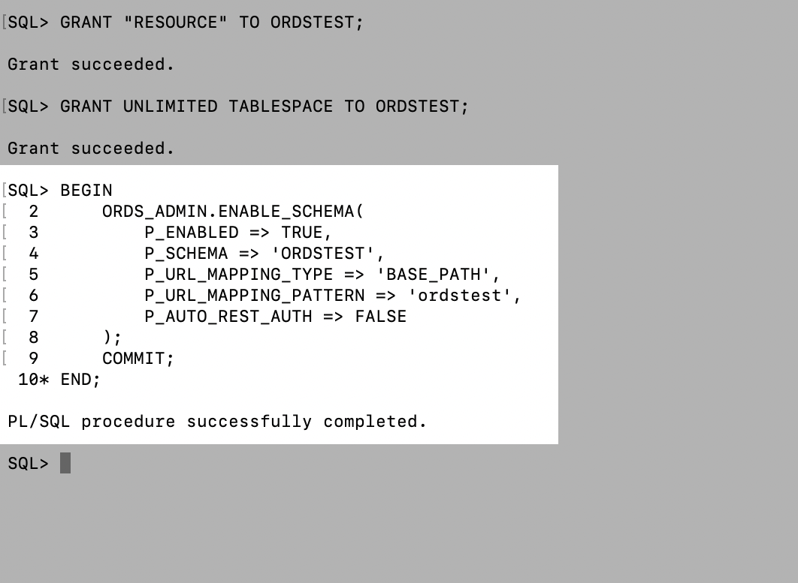 *Executing the ORDS.ENABLE_SCHEMA PL/SQL Procedure*

NOTE: The P_URL_MAPPING_PATTERN parameter *must be* lowercase.

NOTE: Notice how the P_AUTO_REST_AUTH parameter is set to FALSE. Setting this parameter to FALSE allows any user access to the ORDS metadata catalogue without the need for user authentication.

TIP: Additional information on the ORDS PL/SQL Package can be found in [this section](https://docs.oracle.com/en/database/oracle/oracle-rest-data-services/23.1/orddg/ORDS-reference.html#GUID-E4476C14-01B1-4EA4-94D3-73B92C8C9AB3) of the Oracle REST Data Services Developer’s Guide.

### Connect as the new user and auto-REST-enable a table

Now that the ORDSTEST user schema has been REST-enabled. You may access Database Actions, as the ORDSTEST user.

1. Navigate to this URL: http://localhost:8080/ords/sql-developer

* 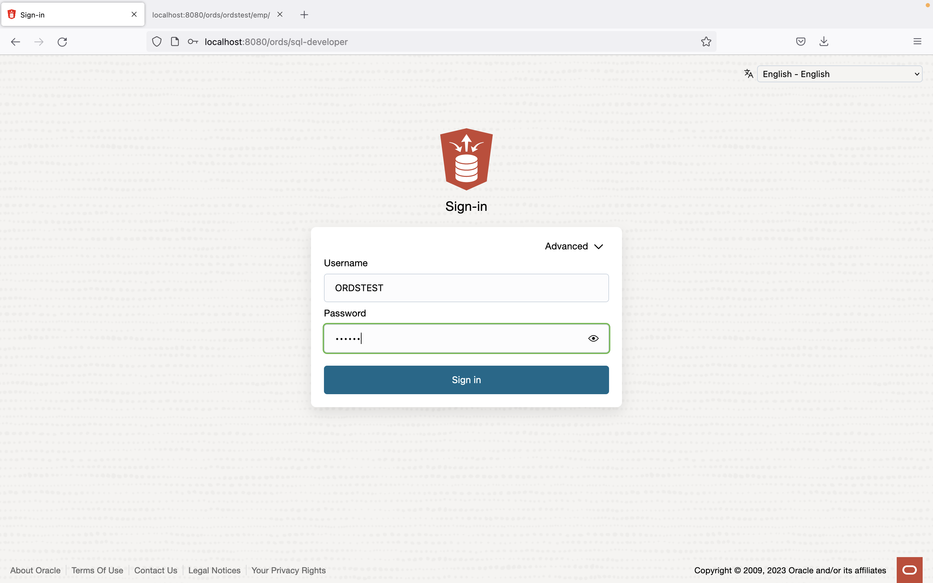 *Navigating to SQL Developer Web*

1. Next, sign in as the ORDSTEST user with the username ORDSTEST and Password oracle (your password may differ). And click the Sign in button.

* Once the page loads, you will see the Database Actions Launchpad, as well as the various categories available to the ORDSTEST user.
* 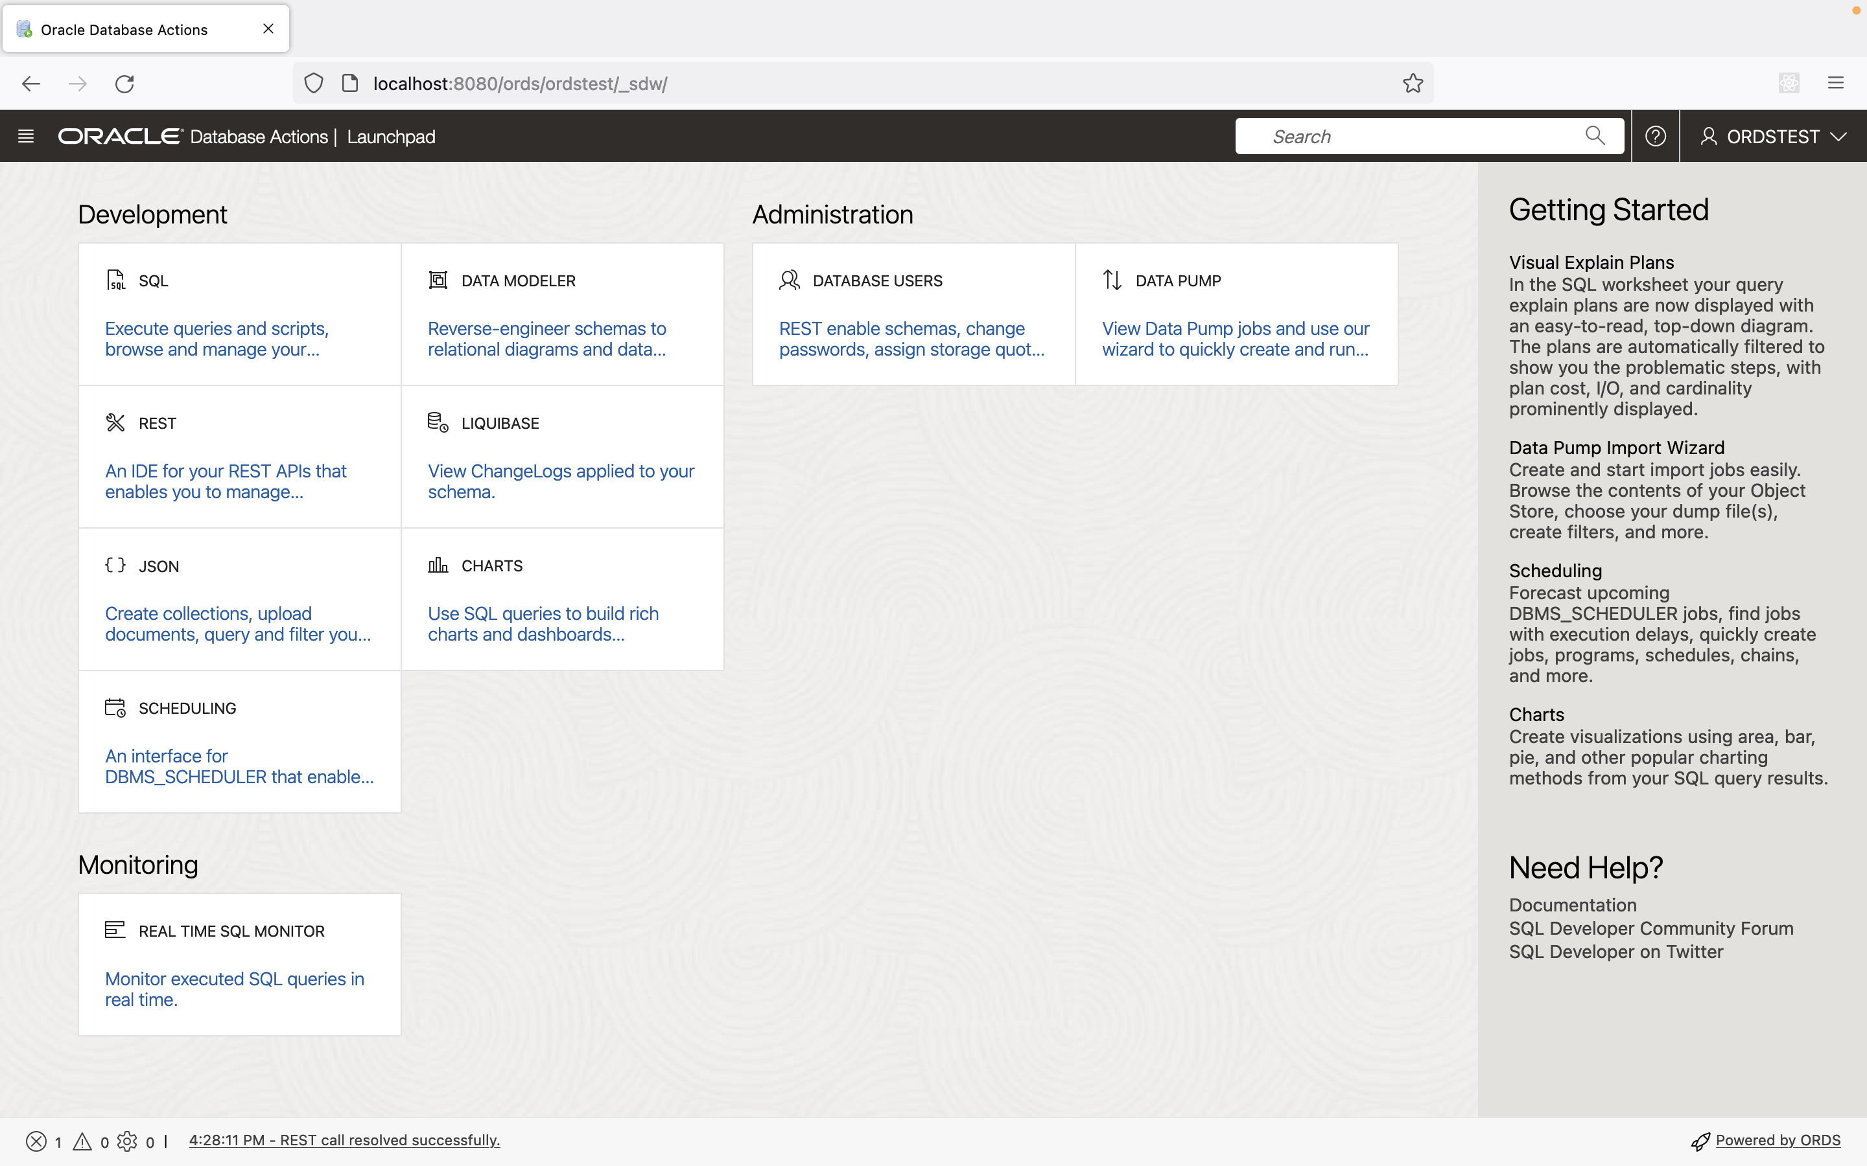 *The Database Actions Launchpad*

### Connect as the new user and auto REST-enable a table

IMPORTANT: The following tasks will be completed as the ORDSTEST user.

1. From the Database Actions Launchpad, select SQL, under the Development category of the dashboard.

* 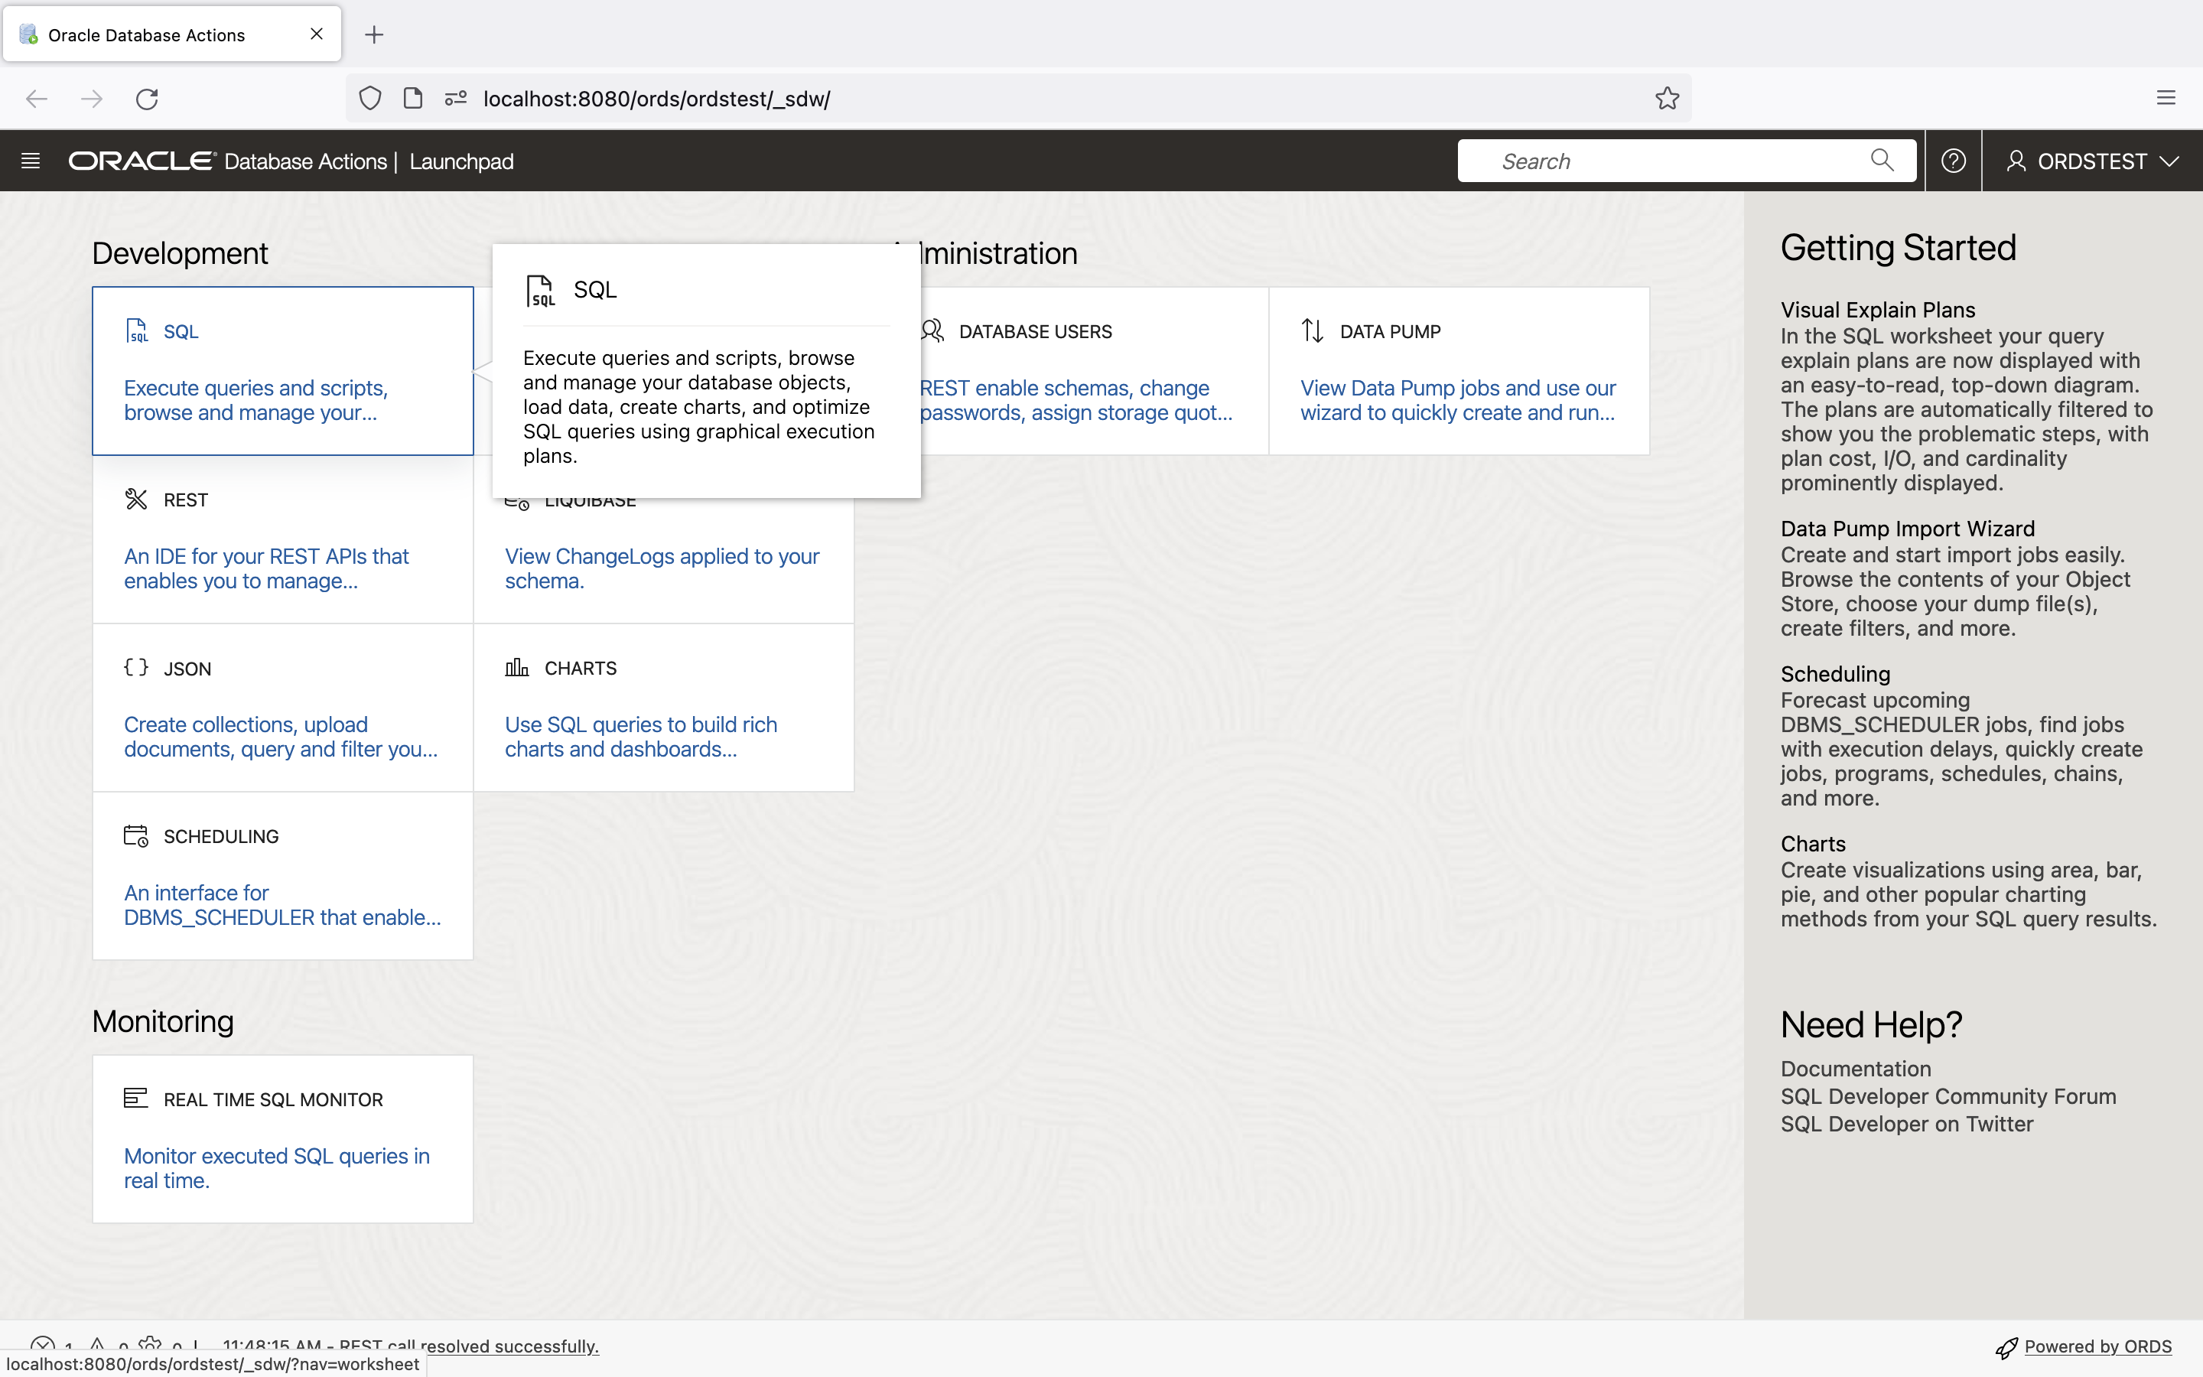 *Navigating to the SQL Worksheet*

1. Once the SQL Worksheet loads, use the SQL below to create the EMP table.

* CREATE TABLE EMP (  
   EMPNO NUMBER(4,0),  
   ENAME VARCHAR2(10 BYTE),  
   JOB VARCHAR2(9 BYTE),  
   MGR NUMBER(4,0),  
   HIREDATE DATE,  
   SAL NUMBER(7,2),  
   COMM NUMBER(7,2),  
   DEPTNO NUMBER(2,0),  
   CONSTRAINT PK_EMP PRIMARY KEY (EMPNO)  
   );

1. With the EMP table successfully created, insert the following sample data:

* Insert into EMP (EMPNO,ENAME,JOB,MGR,HIREDATE,SAL,COMM,DEPTNO) values  
  (7369,'SMITH','CLERK',7902,to_date('17-DEC-80','DD-MON-RR'),800,null,20);  
  Insert into EMP (EMPNO,ENAME,JOB,MGR,HIREDATE,SAL,COMM,DEPTNO) values  
  (7499,'ALLEN','SALESMAN',7698,to_date('20-FEB-81','DD-MON-RR'),1600,300,30);  
  Insert into EMP (EMPNO,ENAME,JOB,MGR,HIREDATE,SAL,COMM,DEPTNO) values  
  (7521,'WARD','SALESMAN',7698,to_date('22-FEB-81','DD-MON-RR'),1250,500,30);  
  Insert into EMP (EMPNO,ENAME,JOB,MGR,HIREDATE,SAL,COMM,DEPTNO) values  
  (7566,'JONES','MANAGER',7839,to_date('02-APR-81','DD-MON-RR'),2975,null,20);  
  Insert into EMP (EMPNO,ENAME,JOB,MGR,HIREDATE,SAL,COMM,DEPTNO) values  
  (7654,'MARTIN','SALESMAN',7698,to_date('28-SEP-81','DD-MON-RR'),1250,1400,30);   
  Insert into EMP (EMPNO,ENAME,JOB,MGR,HIREDATE,SAL,COMM,DEPTNO) values  
  (7698,'BLAKE','MANAGER',7839,to_date('01-MAY-81','DD-MON-RR'),2850,null,30);  
  Insert into EMP (EMPNO,ENAME,JOB,MGR,HIREDATE,SAL,COMM,DEPTNO) values  
  (7782,'CLARK','MANAGER',7839,to_date('09-JUN-81','DD-MON-RR'),2450,null,10);  
  Insert into EMP (EMPNO,ENAME,JOB,MGR,HIREDATE,SAL,COMM,DEPTNO) values  
  (7788,'SCOTT','ANALYST',7566,to_date('19-APR-87','DD-MON-RR'),3000,null,20);  
  Insert into EMP (EMPNO,ENAME,JOB,MGR,HIREDATE,SAL,COMM,DEPTNO) values  
  (7839,'KING','PRESIDENT',null,to_date('17-NOV-81','DD-MON-RR'),5000,null,10);  
  Insert into EMP (EMPNO,ENAME,JOB,MGR,HIREDATE,SAL,COMM,DEPTNO) values  
  (7844,'TURNER','SALESMAN',7698,to_date('08-SEP-81','DD-MON-RR'),1500,0,30);  
  Insert into EMP (EMPNO,ENAME,JOB,MGR,HIREDATE,SAL,COMM,DEPTNO) values  
  (7876,'ADAMS','CLERK',7788,to_date('23-MAY-87','DD-MON-RR'),1100,null,20);  
  Insert into EMP (EMPNO,ENAME,JOB,MGR,HIREDATE,SAL,COMM,DEPTNO) values  
  (7900,'JAMES','CLERK',7698,to_date('03-DEC-81','DD-MON-RR'),950,null,30);  
  Insert into EMP (EMPNO,ENAME,JOB,MGR,HIREDATE,SAL,COMM,DEPTNO) values  
  (7902,'FORD','ANALYST',7566,to_date('03-DEC-81','DD-MON-RR'),3000,null,20);  
  Insert into EMP (EMPNO,ENAME,JOB,MGR,HIREDATE,SAL,COMM,DEPTNO) values  
  (7934,'MILLER','CLERK',7782,to_date('23-JAN-82','DD-MON-RR'),1300,null,10);  
  commit;
* 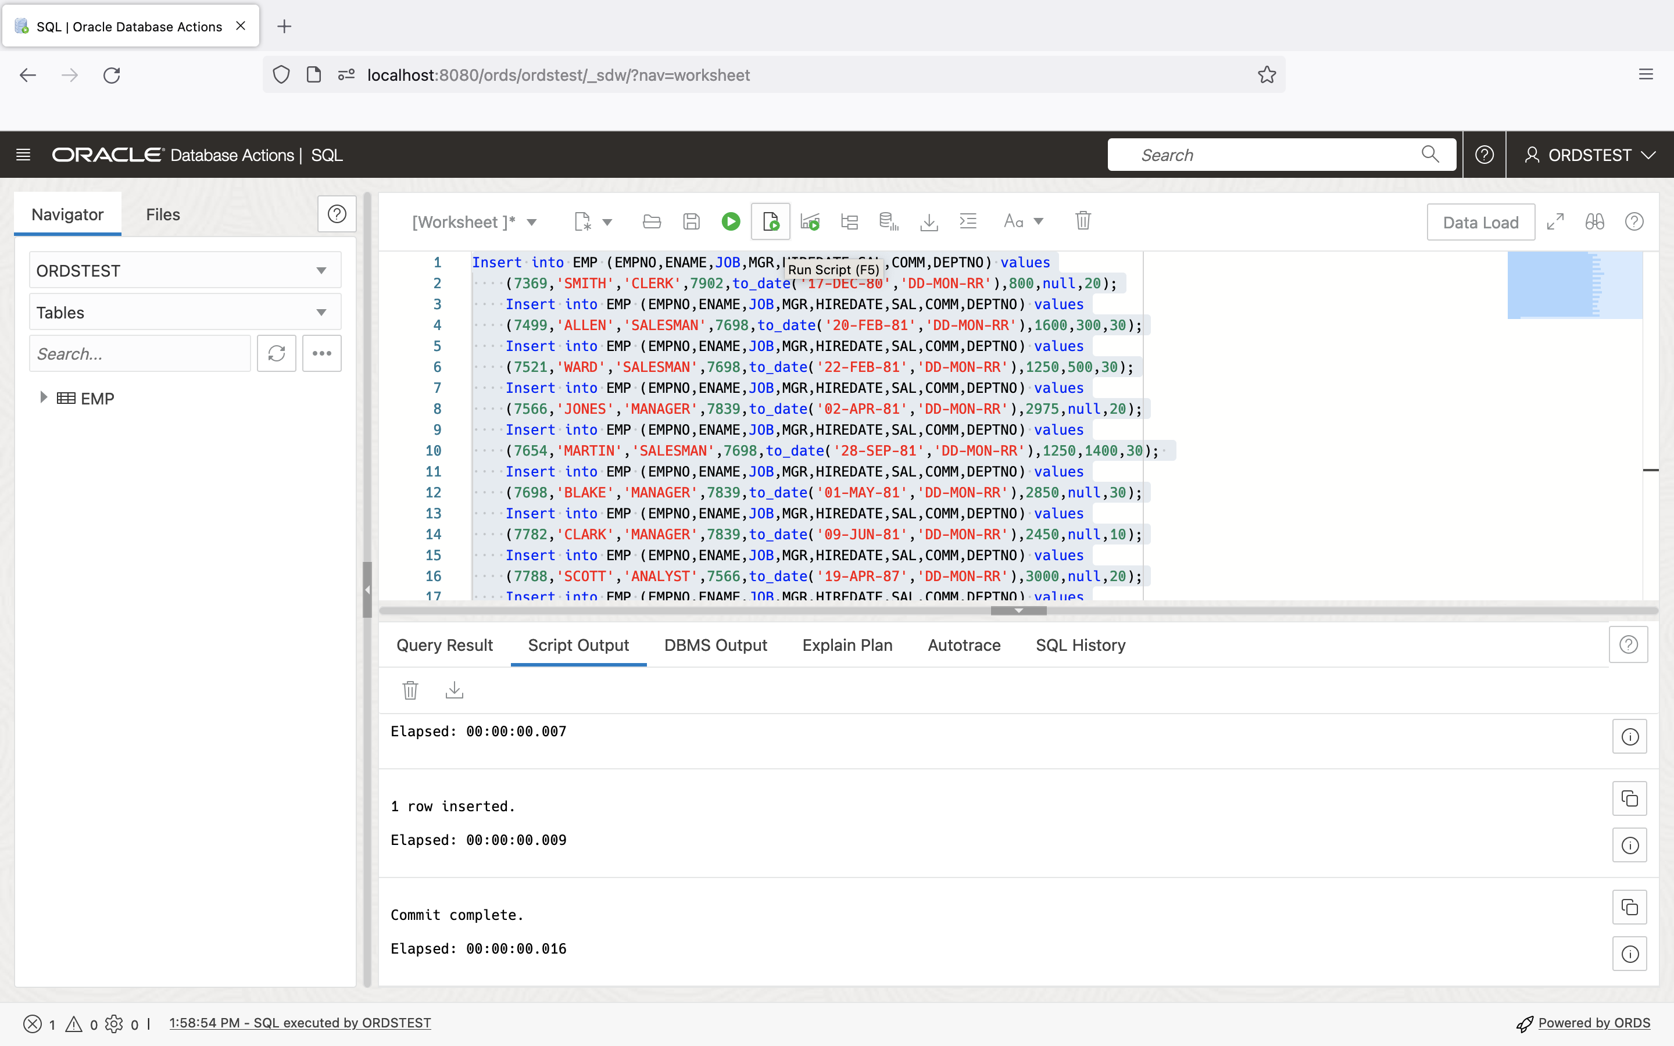 *Inserting data into the EMP table*

1. With the EMP table created and populated with data, you will now auto-REST enable it. From the Navigator Panel, right mouse-click on the table name, navigate to REST, then click Enable.

* 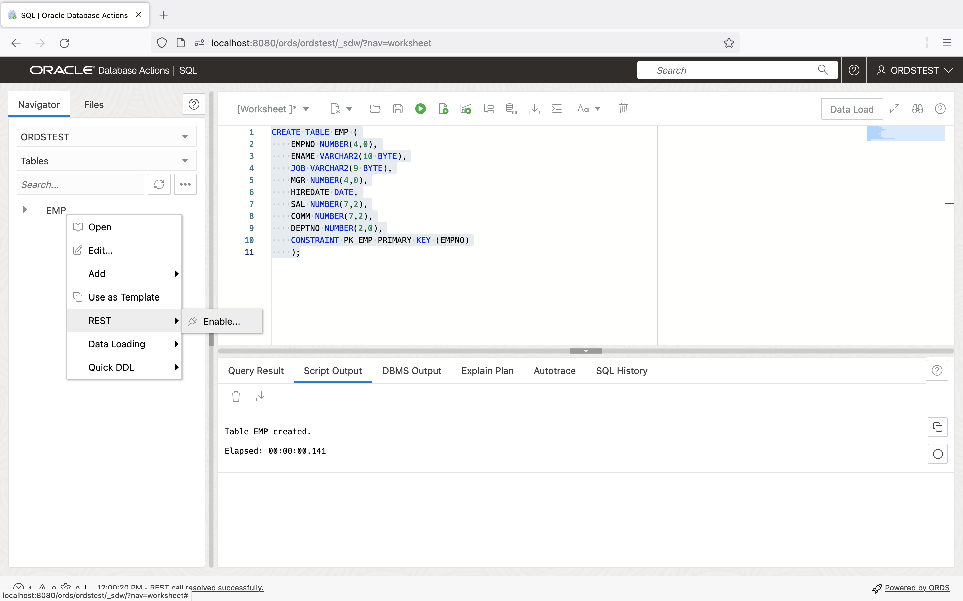 *Using the Navigator Panel to select REST > Enable*
* A REST Enable Object slider will appear. After inspecting the parameters that have automatically been generated for you, click the Enable button located at the bottom of the slider.
* 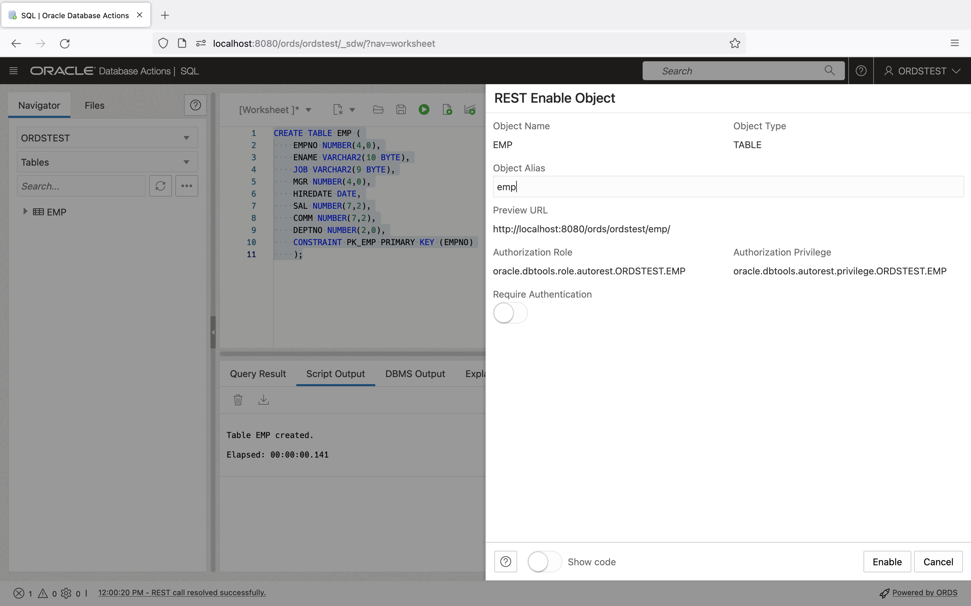 *Reviewing the REST Enable Object Slider*`
* A message slider will appear, confirming that the EMP table has been REST-enabled.
* 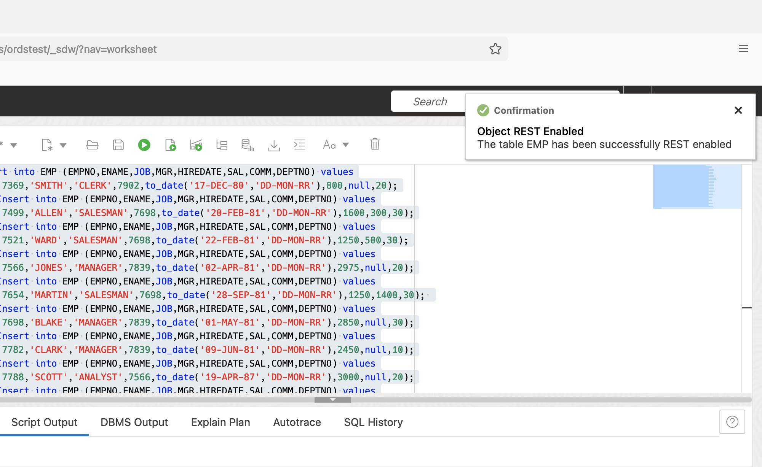 *Confirmation that the EMP table has been REST-enabled*

### Testing the auto REST-enabled endpoint

1. You can quickly identify database objects that have been auto-REST enabled by looking for the plug icon next to it’s name.

* 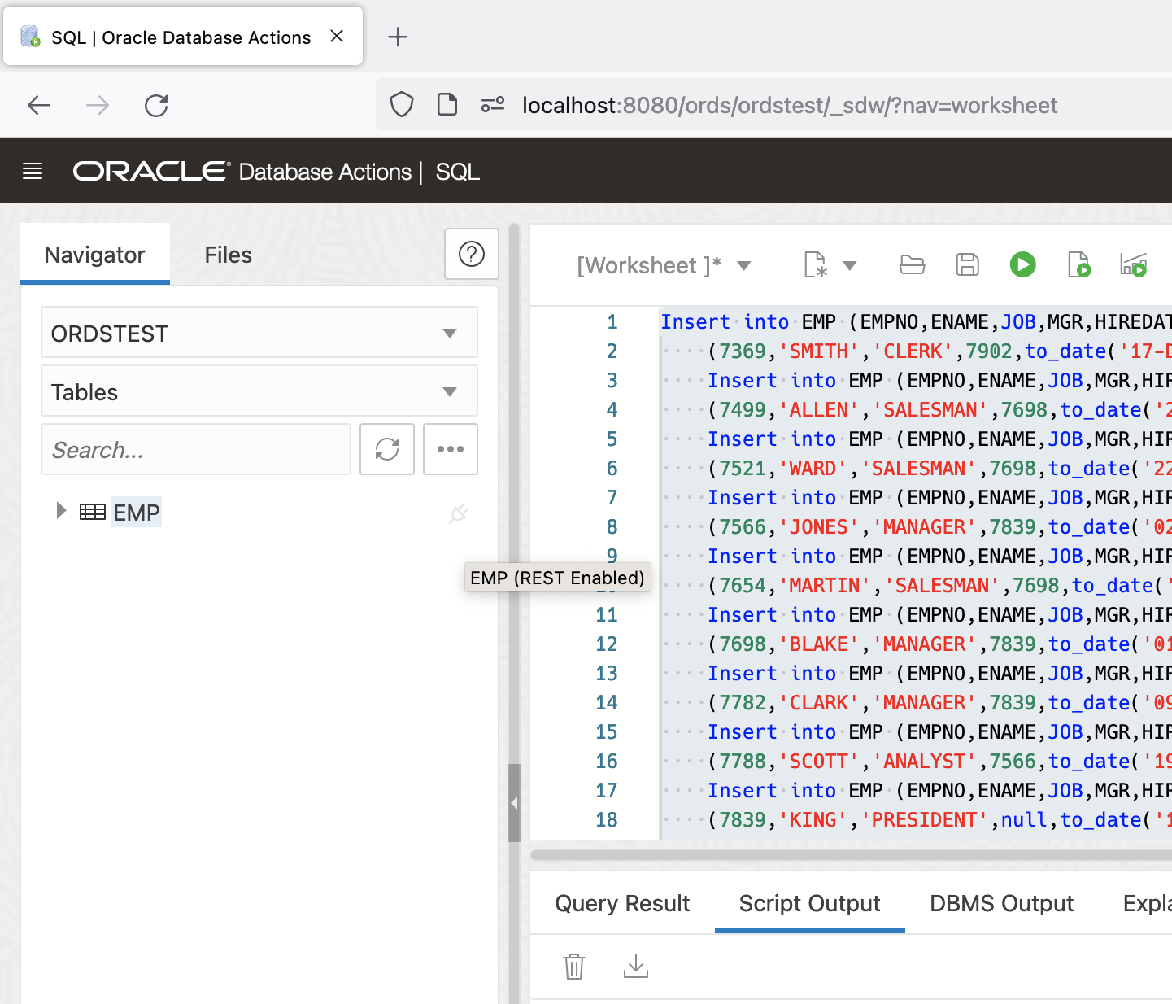 *Plug icon indicating a database object has been auto-REST enabled*
* NOTE: Click you may need to click the Refresh button in the Navigator Panel to display this icon.
* 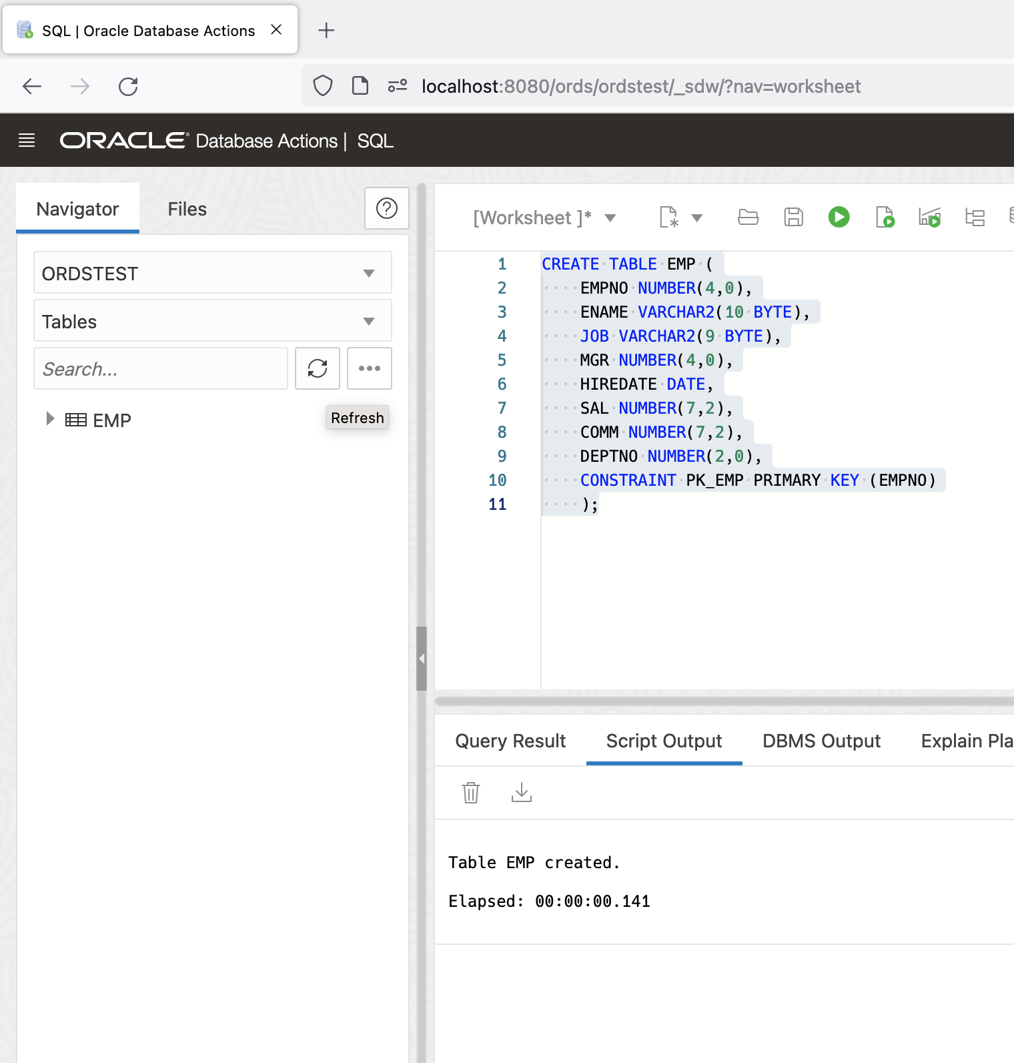 *Clicking the Refresh button to display database objects*

1. You can review and retrieve the REST endpoints for the EMP table by right-clicking on the object’s name then REST then cURL command.

* 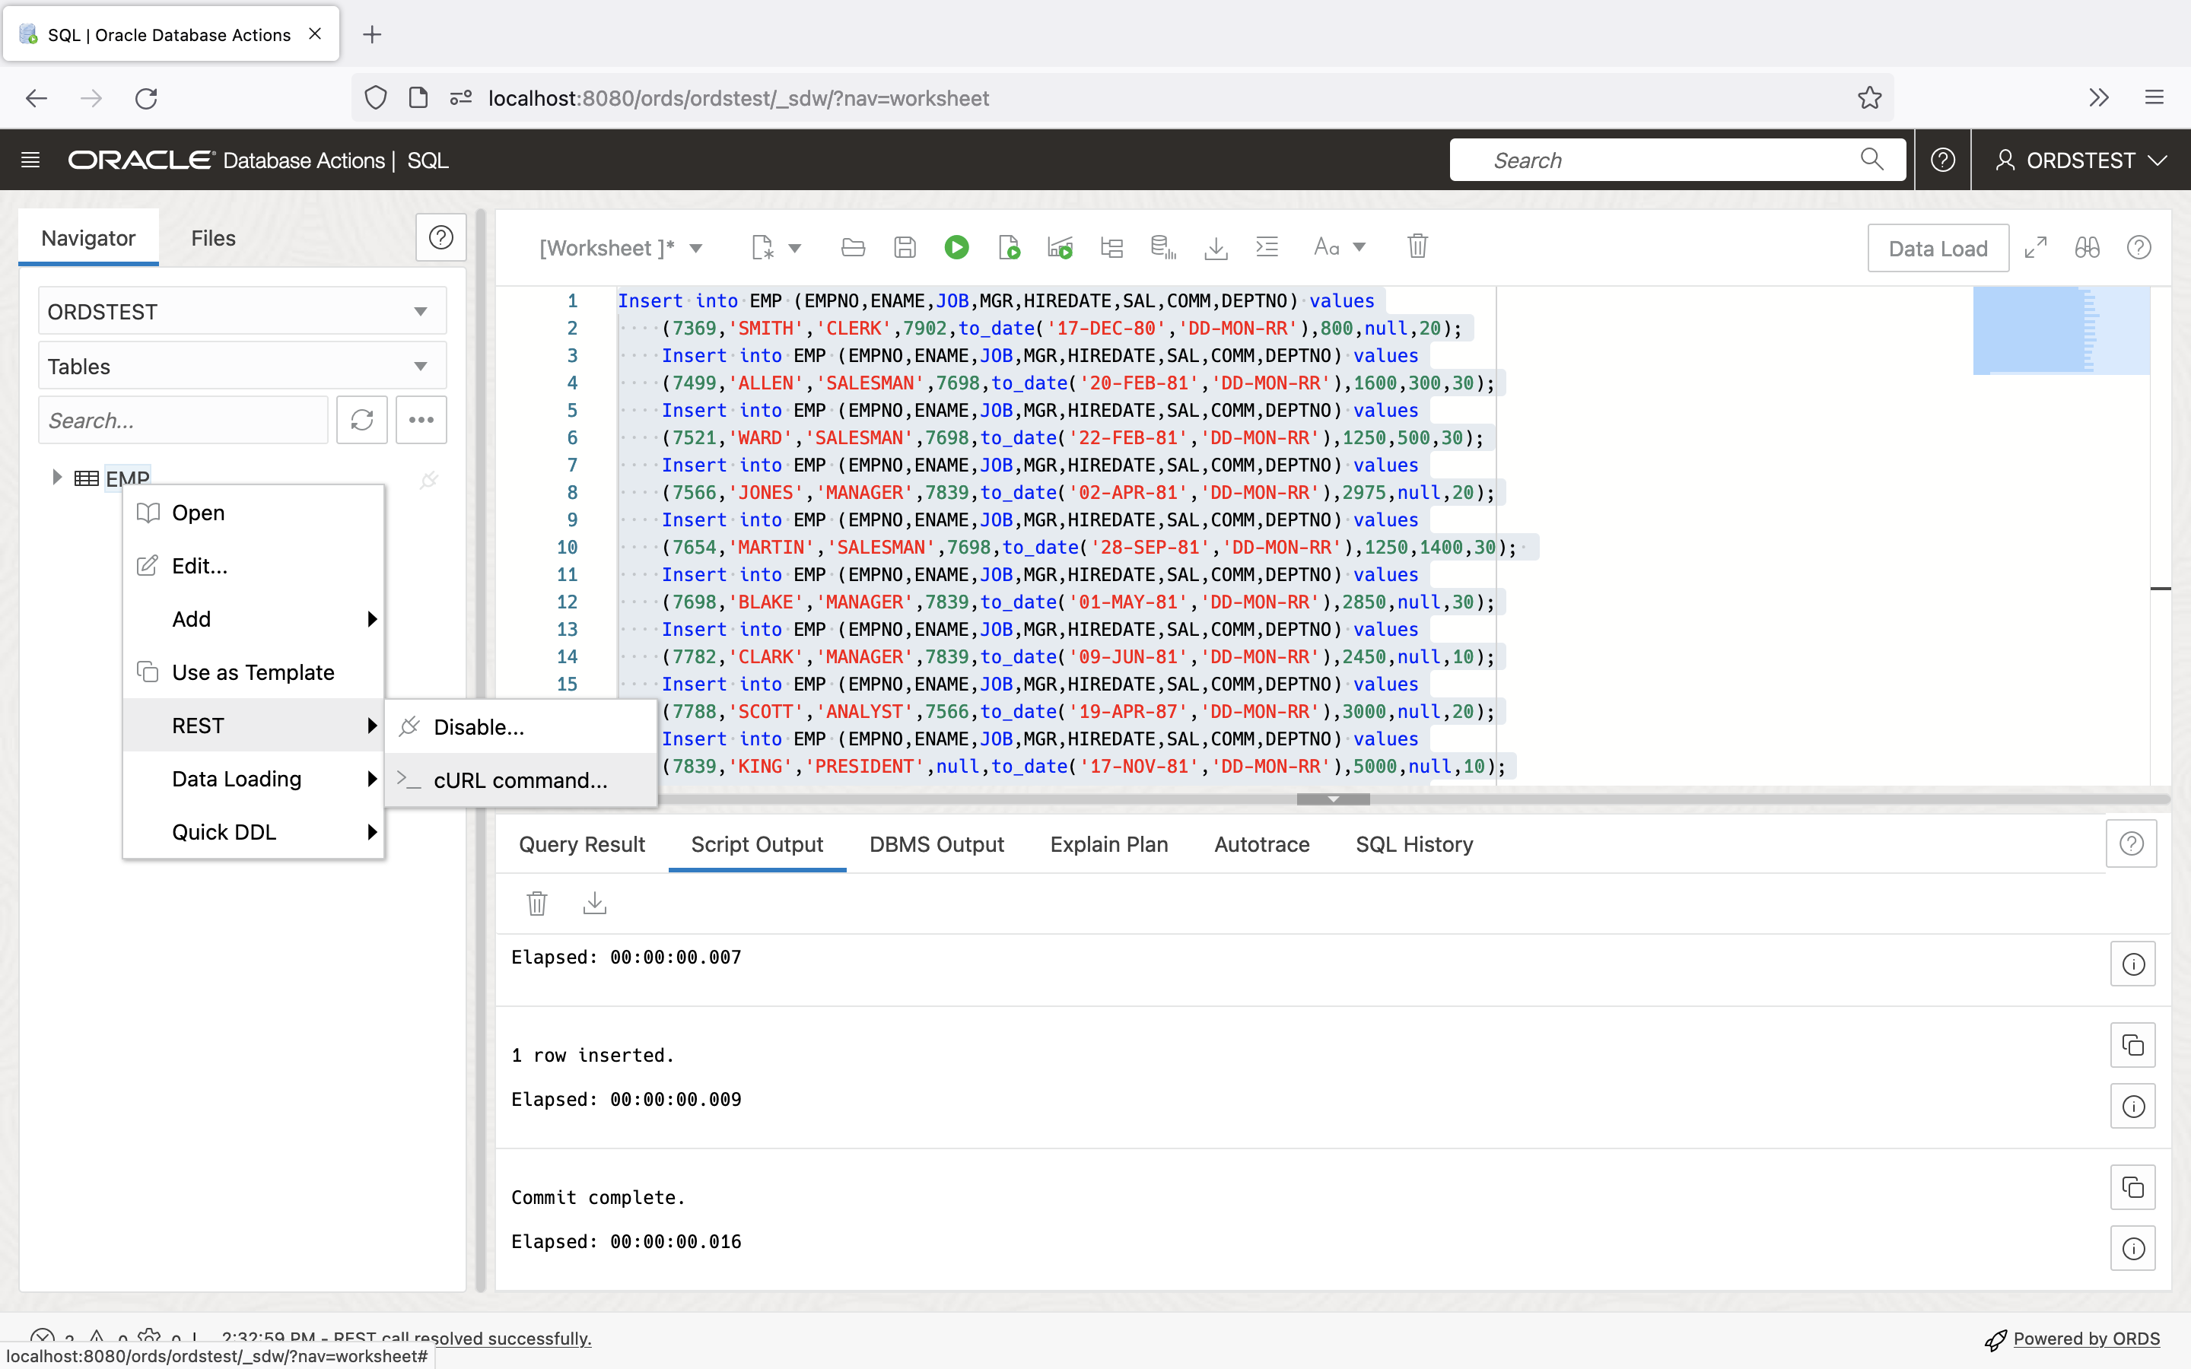 *Navigating to the cURL command menu item*

1. A slider will appear. You’ll notice the various HTTP Methods available to an auto-REST enabled resource.
   * GET ALL
   * GET Single
   * POST
   * BATCH LOAD
   * PUT
   * DELETE

* Copy the URL portion of the GET ALL cURL command.
* 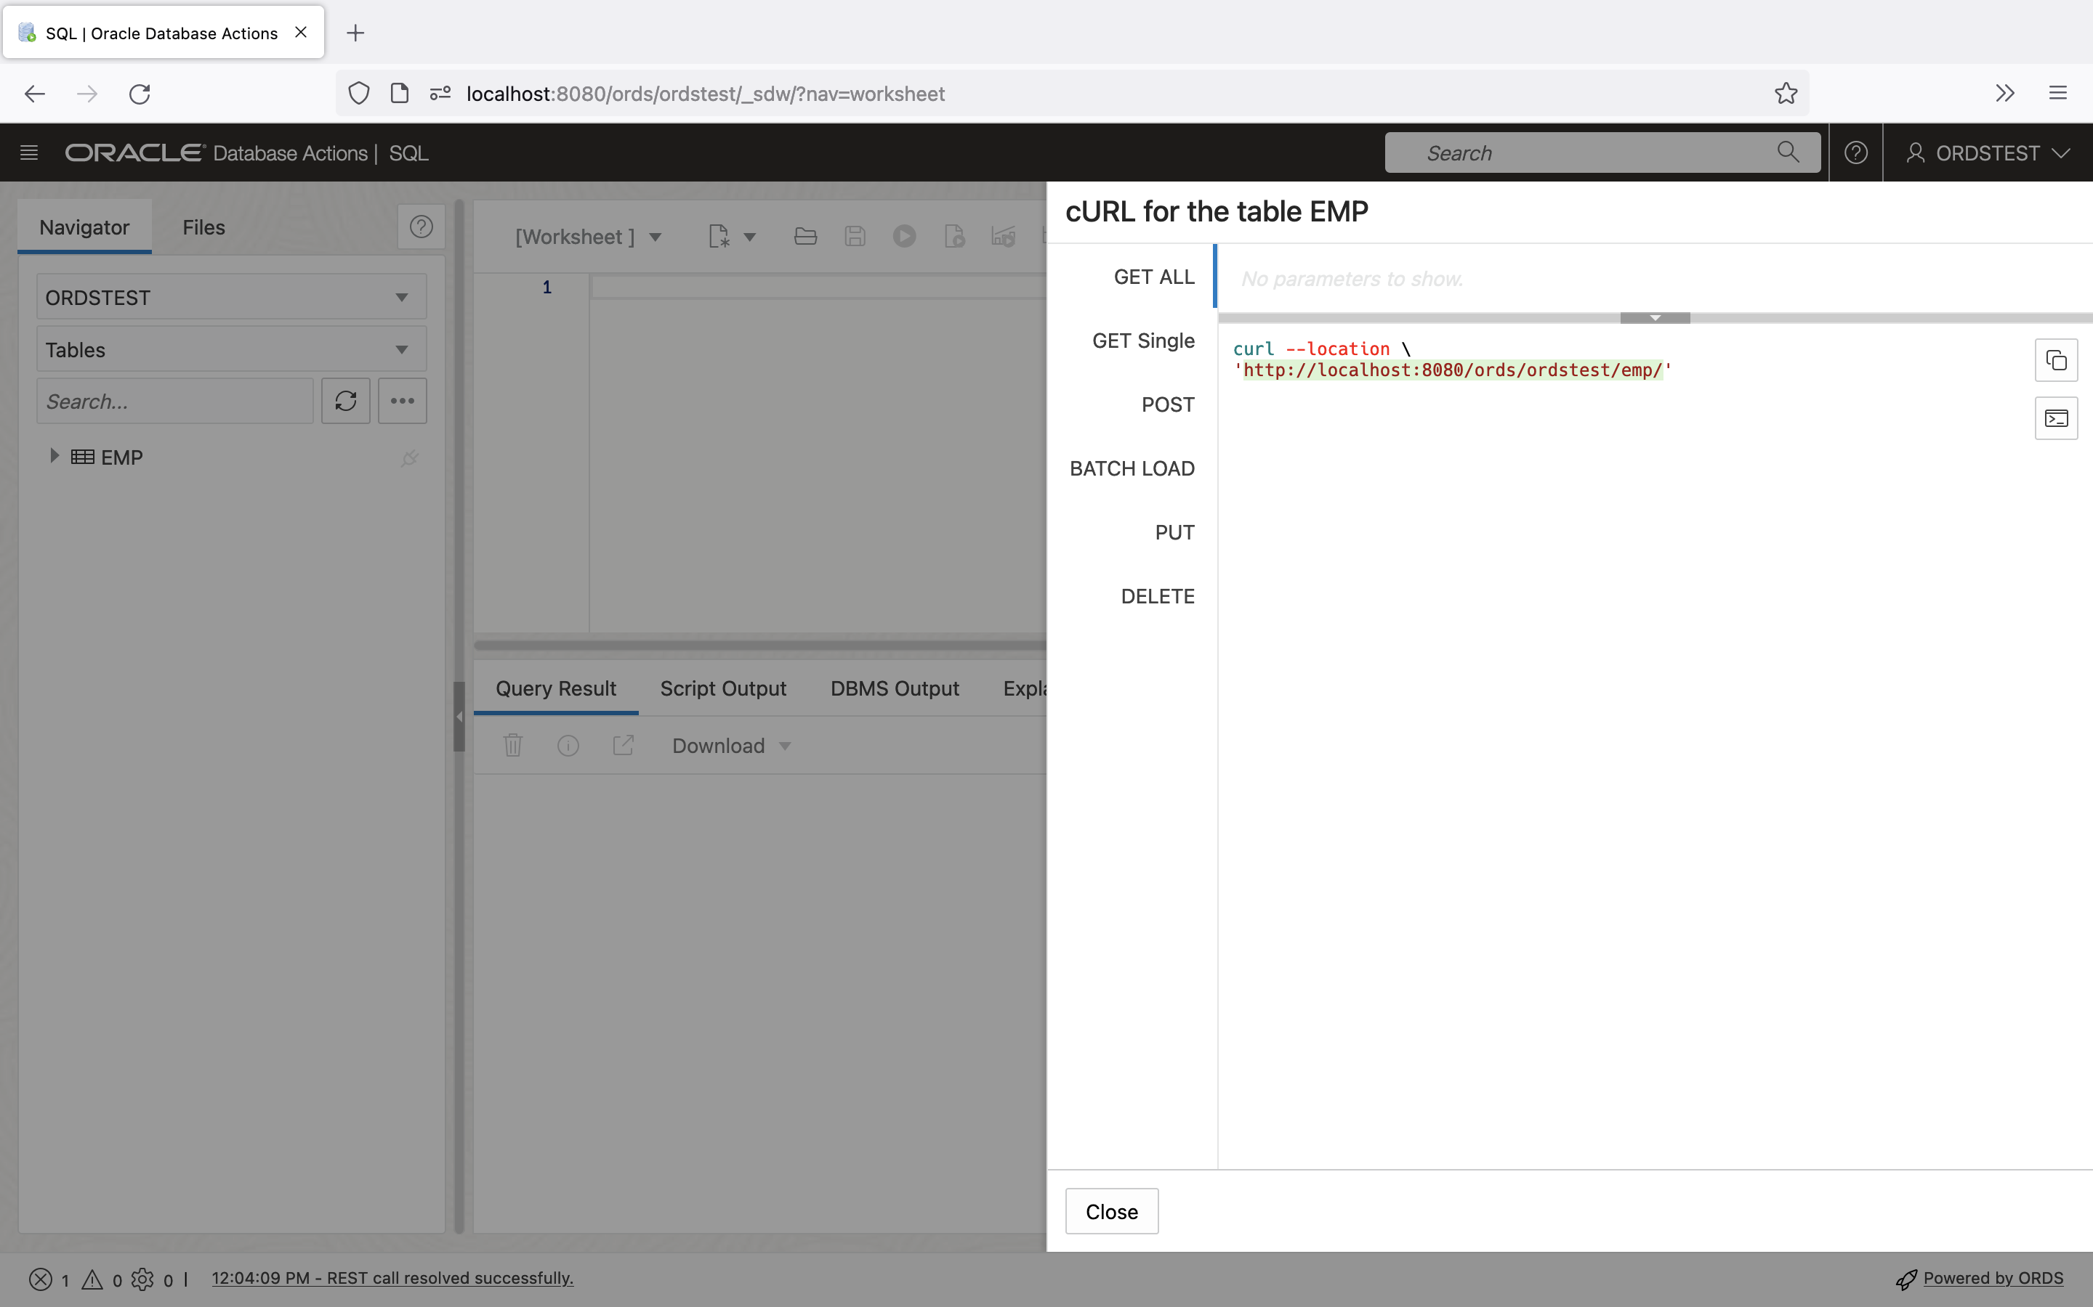 *Copying the GET ALL URL from the cURL command*

1. Open a new browser tab, paste the URL into the Address Bar, and press Enter on your keyboard.

* 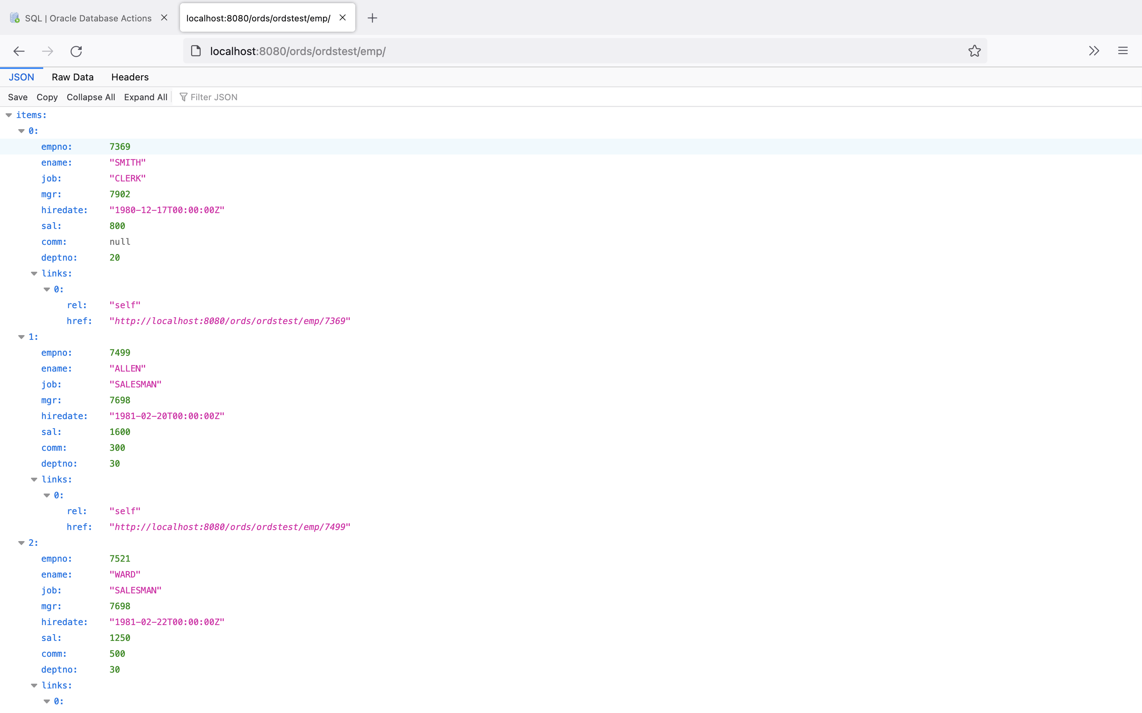 *Reviewing the results of the GET ALL URI in the browser*

1. You will notice a list of the first 25 items in the EMP table. Collapsing the items array, will reveal other helpful links, automatically included with all auto-REST enabled resources.

* 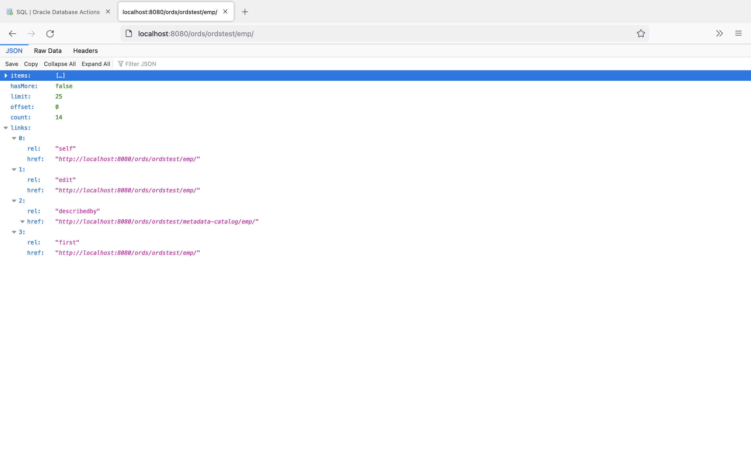 *Collapsing items to reveal additional, helpful links*
* NOTE: ORDS automatically sets pagination to 25 results, although this setting can be changed later if required. This configuration falls outside the scope of this Quick Start Guide.